United Utilities Water
Meter Selection Catalogue

Table of Contents

Foreword. 3
Operating principles of different meter types 4
Available Meters 5
Flow Data 8
Pulse Unit Information 11
Elster Bulk Meter Product selector 16

Foreword.
This document contains a catalogue of water meters which are approved for use by United Utilities Water (UUW) for fiscal use, and these meters may be selected by a new Water Supply Licensee (WSL).

Only water meters contained within this document are available for selection. UUW will not accept the installation of any alternative water meter as a fiscal meter.

All water meters will be provided by UUW. The WSL will have a role in selecting the preferred meter to be used.

This document should be read in conjunction with the following documentation:-

- Operating Code OC1 – Pulsed Output
- Operating Code OC2 – Meter Size Change
- Operating Code OC3 – Meter Testing
- Operating Code OC4 – Alterations to meter location or housing
- Operating Code OC5 – Maintenance activity required
- Operating Code OC6 – Failure of data logging equipment
- Wholesale Supply Common Contract

This document facilitates Licensee requests to upsize, downsize or exchange existing water meters as described in Section 7 ; Section 12 of the Wholesale Supply Common Contract.

Operating principles of different meter types
.
Piston meter (Volumetric).
Piston meters, also known as rotary piston or semi-positive displacement meters, the piston meter operates on the principle of a piston rotating within a chamber of known volume. For each rotation, an amount of water passes through the piston chamber. Through a gear mechanism and, sometimes, a magnetic drive, a needle dial and odometer type display is advanced.

- Accurate at low flow
- Low maintenance

Single jet meter

A single jet meter consists of a simple impeller with radial vanes, impinged upon by a single jet. A magnetic coupling to the register drives directly off the rotor and a needle dial and odometer type display are advanced.

- Low to Medium range meter
- Low headloss across meter

Woltmann meter

The Woltmann meter comprises a rotor with helical blades inserted axially in the flow, much like a ducted fan; it can be considered a type of turbine flow meter. They are commonly referred to as helix meters, and are popular at larger sizes. A magnetic coupling to the register drives directly off the rotor and a needle dial and odometer type display are advanced.

- High flow range meter
- Horizontal or Vertical Installation

Combination Meters

Combination meters combined a volumetric meter and a Voltmann meter in one meter body. During periods of low flow the water is recorded through the volumetric meter. When the flow increases a changeover valve diverts the water through the Voltmann meter.

- Low to high flow range meter
- Suitable for low consumption customers with firefighting facilities
- Horizontal or Vertical Installation

Magnetic flow meters

Magnetic flow meters, often called "mag meter’s” or "electromag’s”, use a magnetic field applied to the metering tube, which results in a potential difference proportional to the flow velocity perpendicular to the flux lines. The potential difference is sensed by electrodes aligned perpendicular to the flow and the applied magnetic field. The physical principle at work is Faraday's law of electromagnetic induction.

- Battery or mains powered
- Bi directional
- Do not require strainers
- No mechanical measuring element
- Suitable for non-potable water

Available Meters

The following meters are available for selection and accepted by UUW.

Size 15mm / 20mm - Sappel Altair (Piston)

- Accurate at low flows
- Supplied with AMR unit attached & paired to meter
- Sizes available – 15mm & 20mm.
- Flow ranges from 5 litres/hr – 5 m³/hr
- Composite meter body
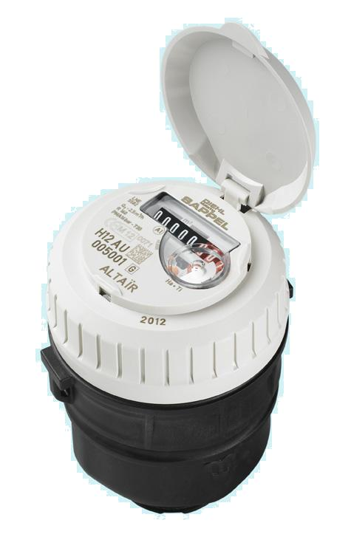
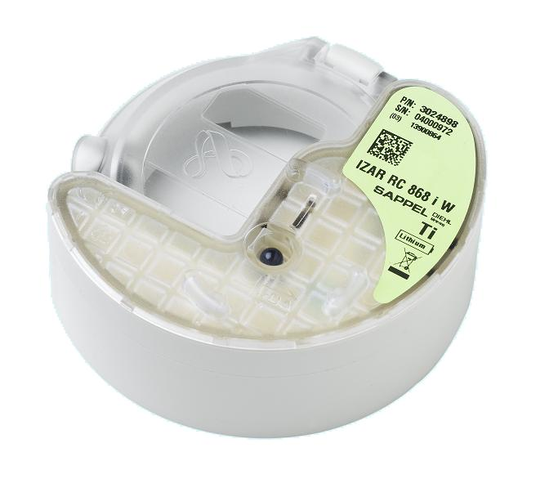
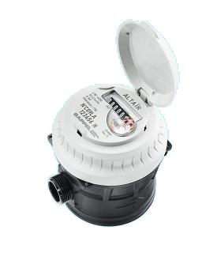

Size 25mm / 40mm - Elster V100 (Piston)
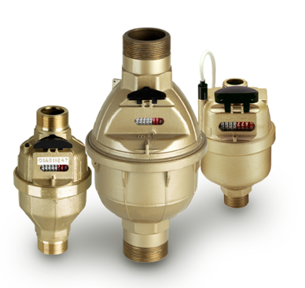
- Accurate at low flows
- Reliable, low maintenance
- Sizes available – 25mm & 40mm
- Flow range from 35 litres/hr – 20 m³/hr
- Magnetic Pulse output available (5 litres/pulse)
- T-Probe pulse unit

Size 25mm / 40mm - Elster V200 (Piston)

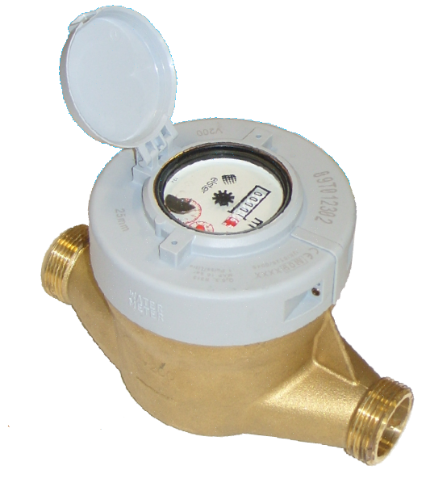
- Accurate at low flows
- Reliable, low maintenance
- Sizes available – 25mm & 40mm
- Flow range from 39.37 litres/hr – 12.5 m³/hr
- Inductive Pulse output (Primary & Secondary available)
- PR6 Pulse Unit

Size 50mm / 100mm Elster S2000 (Single Jet)
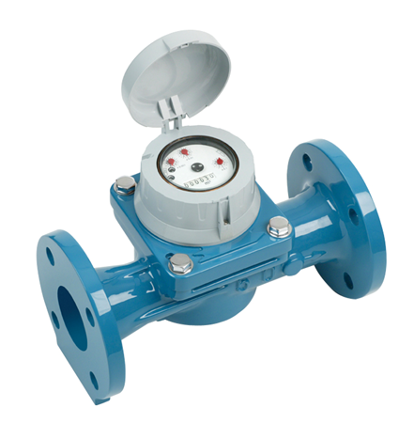

- Low – Mid flow rate meter
- Low headloss across meter
- Sizes available – 50mm/80mm/100mm
- Flow range from – 90 litres/hr – 100 m³/hr
- Inductive Pulse output (Primary & Secondary available)
- PR7 Pulse unit

Size 50mm – 150mm Elster H4000 (Woltmann)
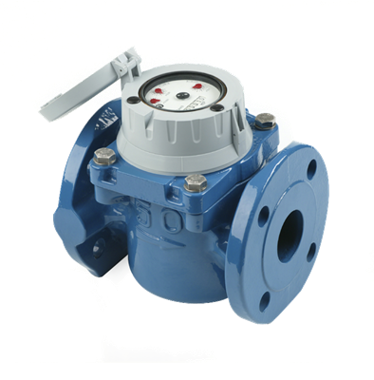
- High flow rate meter
- Sizes available – 50mm/80mm/100mm/150mm.
- Flow range from – 0.35 m³/hr – 600 m³/hr
- Inductive Pulse output (Primary & Secondary available)
- PR7 Pulse unit

Size 50mm – 150mm Elster H5000 (Woltmann)

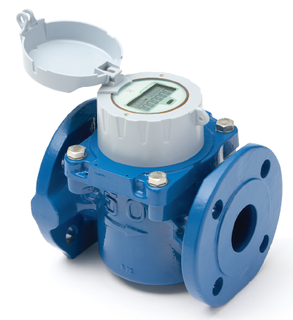
- Wide measuring range
- Retro-fit mechanism into the H4000 body
- Electronic register includes an integrated communications cable
- Electronic register pre-equipped for AMR
- AMR features such as flow rate display, leak detection, tamper alarms and tariffing
- Sizes available 50mm/80mm/100mm/150mm.
- Flow range from 50 litres/hr – 200 m³/hr

Size 50mm – 150mm Elster C4000 (Combination)
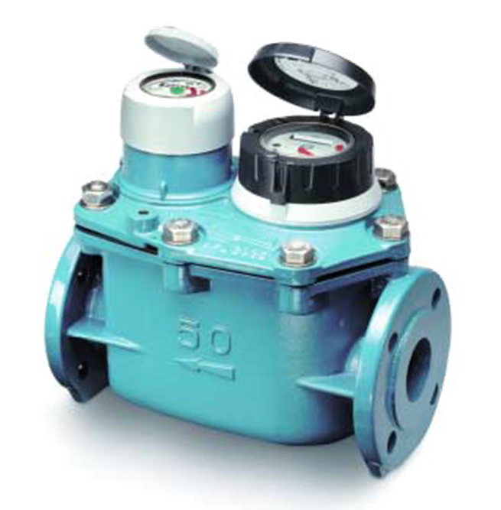

- Accurate for large variations in flow rate
- Sizes available – 50mm/80mm/100mm/150mm*
- Primary and Secondary pulsed outputs available on both dials
- Main meter – PR7 Pulse unit
- By-pass – PR6 Pulse unit

Size 50mm – 200mm Elster Q4000 (Electromagnetic)
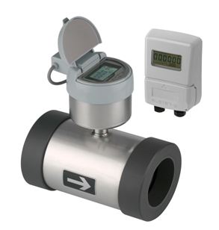
- Electromagnetic meter
- Low headloss across meter
- Low – high flow range
- Bi-directional pulsed output (2 outputs if using the remote display)
- Suitable for non-potable water
- Sizes available 50 – 200 mm
- Flow range from 0.10 m³/hr – 788 m³/hr

Size 50mm – 300mm ABB AquaMaster (Electromagnetic)
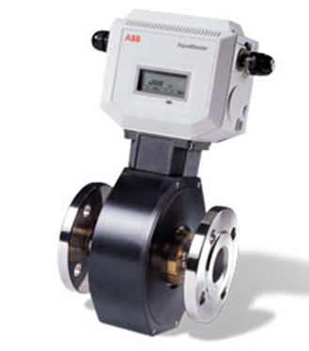

- Electromagnetic meter
- Low headloss across meter
- Low – high flow range
- User defined pulsed output
- Suitable for non-potable water
- Sizes available 50 – 300 mm
- Flow range from 0.10 m³/hr – 788 m³/hr

Size 50mm – 500mm ABB WaterMaster (Electromagnetic)
- Electromagnetic meter
- Low headloss across meter
- Low – high flow range
- User defined pulsed output
- Suitable for non-potable water
- Sizes available 50 – 500 mm
- Flow range from 0.10 m³/hr – 788 m³/hr

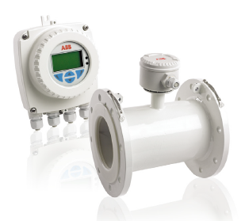

Flow Data

Flow Data
Size | Operating Type | UU recommended Flow Range (overload flow) | Meters Available | Compliance Standards | Output Capability | Number of Outputs Available | Pulse Splitter Compatible
15mm | Piston (in-line) | 5 l/hr – 3.125 m³/hr | Sappel Altair V3 | EN14154, OIML R49, ISO 4064, MID, WIS | AMR meter, no available free output. Requires pulse splitter installation. | 1 (with AMR unit removed) | Yes with specific pulse unit
15mm | Piston (Concentric) | 5 l/hr – 3.125 m³/hr | Sappel Altair V4 | EN14154, OIML R49, ISO 4064, MID, WIS |  | 1 (with AMR unit removed) | Yes with specific pulse unit
20mm | Piston (in-line) | 25 l/hr – 5 m³/hr | Sappel Altair V3 | EN14154, OIML R49, ISO 4064, MID, WIS | AMR meter, no available free output Requires pulse splitter installation. | 1 (with AMR unit removed) | Yes with specific pulse unit
20mm | Piston (Concentric) | 25 l/hr – 5 m³/hr | Sappel Altair V4 | EN14154, OIML R49, ISO 4064, MID, WIS |  | 1 (with AMR unit removed) | Yes with specific pulse unit
25mm | Piston | 35 l/hr – 3.5 m³/hr (7 m³/hr) | Elster V100 | ISO4064, EEC Directive 75/33/EEC, BS5728 Class C | T probe, 5 litres/pulse | 1 | Yes
25mm | Piston | 39 l/hr – 6.3 m³/hr (7.8 m³/hr) | Elster V200 | (MID) Directive 2004/22/EC OIML R49 | PR6 unit, recommend K 1:1 | 2 | Yes
40mm | Piston | 100 l/hr – 10 m³/hr (20 m³/hr) | Elster V100 | ISO4064, EEC Directive 75/33/EEC, BS5728 Class C | T probe, 5 litres/pulse | 1 | Yes
40mm | Piston | 100 l/hr – 10 m³/hr (12.5 m³/hr) | Elster V200 | (MID) Directive 2004/22/EC OIML R49 | PR6 unit, recommend K 1:1 | 2 | Yes
50mm | Single Jet | 90 l/hr – 15 m³/hr (30 m³/hr) | Elster S2000 | ISO4064, BS5728 Class C | PR7 unit, dual output | 2 | Yes
50mm | Woltmann | 0.75 m³/hr – 15 m³/hr (30 m³/hr) | Elster H4000 | ISO4064/BS5728/EEC specification Class B | recommend using K 10:10 | 2 | Yes
50mm | Woltmann | 0.05 m³/hr – 63 m³/hr (79 m³/hr) | Elster H5000 | (MID) Directive 2004/22/EC | Integrated communication cable. | 2, or 4 with splitter | Yes
50mm | Combination | 15 l/hr – 25 m³/hr (50 m³/hr) | Elster C4000 | (MID) Directive 2004/22/EC | Main meter - PR7, Low flow meter - PR6 unit | 2 (on each) | Yes
50mm | Electromagnetic | 0.1 m³/hr – 40 m³/hr (50 m³/hr)** | Elster Q4000 | (MID) Directive 2004/22/EC | MX39 dual output Pulser or MX35 dual output remote display | 2 | Yes
50mm | Electromagnetic | 0.25 m³/hr – 40 m³/hr (50 m³/hr) | ABB AquaMaster | OIML R49 | Variable output determined by user | 1 | Yes
50mm | Electromagnetic | 0.2 m³/hr – 63 m³/hr (79 m³/hr) | ABB WaterMaster | OIML R49, (MID) 2004/22/EC | Pulsed output & 4-20mA signal available | 2 | Yes

80mm | Single Jet | 180 l/hr – 30 m³/hr (60 m³/hr) | Elster S2000 | ISO4064, BS5728 Class C | PR7 unit 10 litres/pulse, dual output | 2 | Yes
80mm | Woltmann | 1.2 m³/hr – 40 m³/hr (80 m³/hr) | Elster H4000 | ISO4064/BS5728/EEC specification Class B | recommend using K 10:10 | 2 | Yes
80mm | Woltmann | 0.05 m3/hr – 63 m3/hr (79 m3/hr) or  0.13 m3/hr - 160 m3/hr (200 m3/hr) | Elster H5000 | (MID) 2004/22/EC | Integrated communication cable. | 2, or 4 with splitter | Yes
80mm | Combination | 15 l/hr – 40 m³/hr (80 m³/hr) | Elster C4000 | (MID) Directive 2004/22/EC | Main meter - PR7, Low flow meter - PR6 unit | 2 (on each) | Yes
80mm | Electromagnetic | 0.25 m³/hr – 100m³/hr (125m³/hr)** | Elster Q4000 | (MID) Directive 2004/22/EC | MX39 dual output Pulser or MX35 dual output remote display | 2 | Yes
80mm | Electromagnetic | 0.63 m³/hr – 100 m³/hr (125 m³/hr) | ABB AquaMaster | OIML R49 | Variable output determined by user | 1 | Yes
80mm | Electromagnetic | 0.51 m³/hr – 160 m³/hr (200 m³/hr) | ABB WaterMaster | OIML R49, (MID) 2004/22/EC | Pulsed output & 4-20mA signal available | 2 | Yes
100mm | Single Jet | 300 l/hr – 50 m³/hr (100 m³/hr) | Elster S2000 | ISO4064, BS5728 Class C | PR7 unit 10 litres/pulse, dual output | 2 | Yes
100mm | Woltmann | 1.8 m³/hr – 60 m³/hr (120 m³/hr) | Elster H4000 | ISO4064/BS5728/EEC specification Class B | recommend using K 10:10 | 2 | Yes
100mm | Woltmann | 0.13 m³/hr – 160 m³/hr (200 m³/hr) | Elster H5000 | (MID) Directive 2004/22/EC | Integrated communication cable. | 2, or 4 with splitter | Yes
100mm | Combination | 15 l/hr – 60 m³/hr (120 m³/hr) | Elster C4000 | (MID) Directive 2004/22/EC | Main meter - PR7, Low flow meter - PR6 unit | 2 (on each) | Yes
100mm | Electromagnetic | 0.4 m³/hr – 160 m³/hr (200 m³/hr)** | Elster Q4000 | (MID) Directive 2004/22/EC | MX39 dual output Pulser or MX35 dual output remote display | 2 | Yes
100mm | Electromagnetic | 1.0 m³/hr – 160 m³/hr (200 m³/hr) | ABB AquaMaster | OIML R49 | Variable output determined by user | 1 | Yes
100mm | Electromagnetic | 0.79 m³/hr – 250 m³/hr (313 m³/hr) | ABB WaterMaster | OIML R49, (MID) 2004/22/EC | Pulsed output & 4-20mA signal available | 2 | Yes
150mm | Woltmann | 4.5 m³/hr – 150 m³/hr (300 m³/hr) | Elster H4000 | ISO4064/BS5728/EEC specification Class B | PR7 unit 100 l/pulse, dual output recommend use K 10:10 | 2 | Yes
150mm | Woltmann | 0.13 m³/hr – 160 m³/hr (200 m³/hr) | Elster H5000 | (MID) Directive 2004/22/EC | Integrated communication cable. | 2, or 4 with splitter | Yes
150mm | Combination | 60 l/hr – 150 m³/hr (300 m³/hr) | Elster C4200 | German National Approval | Main meter - PR7, Low flow meter - T-probe | 2 (on each) | Yes
150mm | Electromagnetic | 1 m³/hr – 400 m³/hr (500 m³/hr)** | Elster Q4000 | CEN pr14154, ISO4064, OIML R49 | MX39 dual output Pulser or MX35 dual output remote display | 2 | Yes
150mm | Electromagnetic | 2.5 m³/hr – 400 m³/hr (500 m³/hr) | ABB AquaMaster | OIML R49 | Variable output determined by user | 1 | Yes
150mm | Electromagnetic | 2.0 m³/hr – 630 m³/hr (788 m³/hr) | ABB WaterMaster | OIML R49, (MID) 2004/22/EC | Pulsed output & 4-20mA signal available | 2 | Yes

200mm | Electromagnetic | 1.6 m³/hr – 630 m³/hr (788 m³/hr)** | Elster Q4000 | (MID) Directive 2004/22/EC | MX39 dual output Pulser or MX35 dual output remote display | 2 | Yes
200mm | Electromagnetic | 3.9 m³/hr – 630 m³/hr (788 m³/hr) | ABB AquaMaster | OIML R49 | Variable output determined by user | 1 | Yes
200mm | Electromagnetic | 3.2 m³/hr – 1000m³/hr (1250m³/hr) | ABB WaterMaster | OIML R49, (MID) 2004/22/EC | Pulsed output & 4-20mA signal available | 2 | Yes
250mm | Electromagnetic | 6.8m³/hr – 1000m³/hr (1250 m³/hr) | ABB AquaMaster | OIML R49 | Variable output determined by user | 1 | Yes
250mm | Electromagnetic | 5.1 m³/hr – 1600m³/hr (2000m³/hr) | ABB WaterMaster | OIML R49, (MID) 2004/22/EC | Pulsed output & 4-20mA signal available | 2 | Yes
250mm | Electromagnetic | 2.5 m³/hr – 1000m³/hr (1250 m³/hr)** | Elster Q4000B Flanged | JIS B8570 conforms to (MID) Directive 2004/22/EC | MX39 dual output Pulser or MX35 dual output remote display | 2 | Yes
300mm | Electromagnetic | 10 m³/hr – 1600 m³/hr (2000m³/hr) | ABB AquaMaster | OIML R49 | Variable output determined by user | 1 | Yes
300mm | Electromagnetic | 7.9 m³/hr – 2500m³/hr (3125m³/hr) | ABB WaterMaster | OIML R49, (MID) 2004/22/EC | Pulsed output & 4-20mA signal available | 2 | Yes
300mm | Electromagnetic | 2.5 m³/hr – 1000m³/hr (1250 m³/hr)** | Elster Q4000B Flanged | JIS B8570 conforms to (MID) Directive 2004/22/EC | MX39 dual output Pulser or MX35 dual output remote display | 2 | Yes
350mm | Electromagnetic | 25 m³/hr – 1600 m³/hr (2000m³/hr) | ABB AquaMaster | OIML R49 | Variable output determined by user | 1 | Yes
350mm | Electromagnetic | 12.7m³/hr – 4000m³/hr (5000m³/hr) | ABB WaterMaster | OIML R49, (MID) 2004/22/EC | Pulsed output & 4-20mA signal available | 2 | Yes
400mm | Electromagnetic | 40 m³/hr – 2500 m³/hr (3125m³/hr) | ABB AquaMaster | OIML R49 | Variable output determined by user | 1 | Yes
400mm | Electromagnetic | 12.7m³/hr – 4000m³/hr (5000m³/hr) | ABB WaterMaster | OIML R49, (MID) 2004/22/EC | Pulsed output & 4-20mA signal available | 2 | Yes

Pulse Unit Data

Pulse Unit Information
Make | Size | Model | Year | Pulse Enabled | Pulse Type | Pulse switch | Pulse rates Output 1 | Pulse rates Output 2 | Comments
Sappel | 15mm | Altair | up to 2010 | Yes* | Magnetic | Sappel Pulsar V3 (Hall) | 1 | N/A | Please note that some internal Sappel meters may already be AMR  From 2012 ALL Sappel meters will be AMR
Sappel | 15mm | Altair | 2010 - present | Yes** | Magnetic & Inductive | Sappel Pulsar V3 (Hall) or Sappel RCi 3.5 (Ind) | 1 | N/A | Please note that some internal Sappel meters may already be AMR  From 2012 ALL Sappel meters will be AMR
Sappel | 20mm | Altair | up to 2010 | Yes* | Magnetic | Sappel Pulsar V3 (Hall) | 1 | N/A | Please note that some internal Sappel meters may already be AMR  From 2012 ALL Sappel meters will be AMR
Sappel | 20mm | Altair | 2010 - present | Yes** | Magnetic & Inductive | Sappel Pulsar V3 (Hall) or Sappel RCi 3.5 (Ind) | 1 | N/A | Please note that some internal Sappel meters may already be AMR  From 2012 ALL Sappel meters will be AMR
Elster/Kent | 15 & 20mm | V210/V200 | up to 2006 | Yes | Magnetic | MSN pulse unit | 1 | N/A
Elster/Kent | 15 & 20mm | V210/V200 | 2006 - present | Yes | Inductive | PR6 | 1 | 1
Elster/Kent | 15 & 20mm | PSM | up to 1997 | No | N/A | N/A | N/A | N/A | Recommend exchanging meter - NB new meter will be a Sappel AMR
Elster/Kent | 15 & 20mm | PSMT | 1997 - present | Yes | Magnetic | T-Probe | 0.5 | N/A
Elster/Kent | 15 & 20mm | V100 |  | Yes | Magnetic | T-Probe | 0.5 | N/A
Elster/Kent | 25mm | V210/V200 | up to 2006 | Yes | Magnetic | MSN pulse unit | 1 | N/A
Elster/Kent | 25mm | V210/V200 | 2006 - present | Yes | Inductive | PR6 | 1 | 1
Elster/Kent | 25mm | PSM | up to 1997 | No | N/A | N/A | N/A | N/A | Recommend exchanging meter
Elster/Kent | 25mm | PSMT | from 1997 | Yes | Magnetic | T-Probe | 5 | N/A
Elster/Kent | 25mm | V100 |  | Yes | Magnetic | T-Probe | 5 | N/A
Elster/Kent | 40mm | PSM | up to 1997 | No | N/A | N/A | N/A | N/A | Recommend exchanging meter
Elster/Kent | 40mm | PSMT | from 1997 | Yes | Magnetic | T-Probe | 5 | N/A
Elster/Kent | 40mm | V100 |  | Yes | Magnetic | T-Probe | 5 | N/A
Elster/Kent | 50mm | Master |  | Yes | Magnetic | LRP | 1 | N/A
Elster/Kent | 50mm | H3000 |  | Yes | Magnetic | LRP | 10 | N/A
Elster/Kent | 50mm | S2000 |  | Yes | Magnetic | Reed switch | 10 | 1000
Elster/Kent | 50mm | S2000 | 2010 - present | Yes | Inductive | PR7 | 10 | 10
Elster/Kent | 50mm | H4000 |  | Yes | Magnetic | Reed switch | 10 | 1000
Elster/Kent | 50mm | H4000 | 2010 - present | Yes | Inductive | PR7 | 10 | 10
Elster/Kent | 50mm | H5000 |  | Yes | inbuilt | Built in - Meter has a 'flying lead' | 10 | 10
Elster/Kent | 50mm | Q4000 |  | Yes | inbuilt | Built in - Meter has a 'flying lead' | 10 | 1000
Elster/Kent | 80mm | Master |  | Yes | Magnetic | LRP | 10 | N/A
Elster/Kent | 80mm | H3000 |  | Yes | Magnetic | LRP | 10 | N/A
Elster/Kent | 80mm | S2000 |  | Yes | Magnetic | Reed switch | 10 | 1000
Elster/Kent | 80mm | S2000 | 2010 - present | Yes | Inductive | PR7 | 10 | 10
Elster/Kent | 80mm | H4000 |  | Yes | Magnetic | Reed switch | 10 | 1000
Elster/Kent | 80mm | H4000 | 2010 - present | Yes | Inductive | PR7 | 10 | 10
Elster/Kent | 80mm | H5000 |  | Yes | inbuilt | Built in - Meter has a 'flying lead' | 10 | 10
Elster/Kent | 80mm | Q4000 |  | Yes | inbuilt | Built in - Meter has a 'flying lead' | 10 | 10
Elster/Kent | 100mm | Master |  | Yes | Magnetic | LRP | 10 | N/A
Elster/Kent | 100mm | H3000 |  | Yes | Magnetic | LRP | 10 | N/A
Elster/Kent | 100mm | S2000 |  | Yes | Magnetic | Reed switch | 10 | 1000
Elster/Kent | 100mm | S2000 | 2010 - present | Yes | Inductive | PR7 | 10 | 10
Elster/Kent | 100mm | H4000 |  | Yes | Magnetic | Reed switch | 10 | 1000
Elster/Kent | 100mm | H4000 | 2010 - present | Yes | Inductive | PR7 | 10 | 10
Elster/Kent | 100mm | H5000 |  | Yes | inbuilt | Built in - Meter has a 'flying lead' | 10 | 10
Elster/Kent | 100mm | Q4000 |  | Yes | inbuilt | Built in - Meter has a 'flying lead' | 10 | 10
Elster/Kent | 150mm | H3000 |  | Yes | Magnetic | LRP | 100 | N/A
Elster/Kent | 150mm | H4000 |  | Yes | Magnetic | Reed switch | 100 | 10000
Elster/Kent | 150mm | H4000 | 2010 - present | Yes | Inductive | PR7 | 100 | 100
Elster/Kent | 150mm | H5000 |  | Yes | inbuilt | Built in - Meter has a 'flying lead' | 100 | 100
Elster/Kent | 150mm | Q4000 |  | Yes | inbuilt | Built in - Meter has a 'flying lead' | 100 | 100
Schlumberger | 15mm | Aquadis P40/P40M |  | Yes | Inductive | Cyble Sensor | 1 | N/A | Requires extra care during installation and identifying pulse rates
Schlumberger | 20mm | Aquadis |  | Yes | Inductive | Cyble Sensor | 1 |  | Requires extra care during installation and identifying pulse rates
Schlumberger | 25mm | Aquadis |  | Yes | Inductive | Cyble Sensor | 1 |  | Requires extra care during installation and identifying pulse rates
Schlumberger | 40mm | Aquadis |  | Yes | Inductive | Cyble Sensor | 1 |  | Requires extra care during installation and identifying pulse rates
Schlumberger | 40mm | Flowstar M |  | Yes | Inductive | Cyble Sensor | 1 |  | Requires extra care during installation and identifying pulse rates
Schlumberger | 50mm | Flowstar M |  | Yes | Inductive | Cyble Sensor | 10 |  | Requires extra care during installation and identifying pulse rates
Schlumberger | 50mm | Woltex |  | Yes | Inductive | Cyble Sensor | 10 |  | Requires extra care during installation and identifying pulse rates
Schlumberger | 80mm | Flowstar M |  | Yes | Inductive | Cyble Sensor | 10 |  | Requires extra care during installation and identifying pulse rates
Schlumberger | 80mm | Woltex |  | Yes | Inductive | Cyble Sensor | 10 |  | Requires extra care during installation and identifying pulse rates
Schlumberger | 100mm | Flowstar M |  | Yes | Inductive | Cyble Sensor | 10 |  | Requires extra care during installation and identifying pulse rates
Schlumberger | 100mm | Woltex |  | Yes | Inductive | Cyble Sensor | 10 |  | Requires extra care during installation and identifying pulse rates
Schlumberger | 150mm | Woltex |  | Yes | Inductive | Cyble Sensor | 100 |  | Requires extra care during installation and identifying pulse rates
Schlumberger | 200mm | Woltex |  | Yes | Inductive | Cyble Sensor | 100 |  | Requires extra care during installation and identifying pulse rates
ABB | All Sizes | AquaMaster |  | Yes | **** | Contact meter services for additional information | **** | ****
ABB | All Sizes | MagMaster |  | Yes | **** | Contact meter services for additional information | **** | ****
ABB | All Sizes | WaterMaster |  | Yes | **** | Contact meter services for additional information | **** | ****
Socam | 15mm | 501 L |  | See Comments | Not recommended for data logging | Not recommended for data logging | Not recommended for data logging | Not recommended for data logging | Pulse units can be difficult to source any reliability is an issue.  Recommend meter exchange - NB new 15mm meter will be an AMR
Socam | 15mm | 510 PR |  | See Comments | Not recommended for data logging | Not recommended for data logging | Not recommended for data logging | Not recommended for data logging | Pulse units can be difficult to source any reliability is an issue.  Recommend meter exchange - NB new 15mm meter will be an AMR
Socam | 20mm | 501 L |  | See Comments | Not recommended for data logging | Not recommended for data logging | Not recommended for data logging | Not recommended for data logging | Pulse units can be difficult to source any reliability is an issue.  Recommend meter exchange - NB new 20mm meter will be an AMR
Socam | 20mm | 510 PR |  | See Comments | Not recommended for data logging | Not recommended for data logging | Not recommended for data logging | Not recommended for data logging | Pulse units can be difficult to source any reliability is an issue.  Recommend meter exchange - NB new 20mm meter will be an AMR
Socam | 25mm | 501 L |  | See Comments | Not recommended for data logging | Not recommended for data logging | Not recommended for data logging | Not recommended for data logging | Pulse units can be difficult to source any reliability is an issue.  Recommend meter exchange
Socam | 25mm | 510 PR |  | See Comments | Not recommended for data logging | Not recommended for data logging | Not recommended for data logging | Not recommended for data logging | Pulse units can be difficult to source any reliability is an issue.  Recommend meter exchange
Socam | 40mm | 510 PR |  | See Comments | Not recommended for data logging | Not recommended for data logging | Not recommended for data logging | Not recommended for data logging | Pulse units can be difficult to source any reliability is an issue.  Recommend meter exchange
Socam | 50mm | WP |  | See Comments | Not recommended for data logging | Not recommended for data logging | Not recommended for data logging | Not recommended for data logging | Pulse units can be difficult to source any reliability is an issue.  Recommend meter exchange
Socam | 50mm | WS |  | See Comments | Not recommended for data logging | Not recommended for data logging | Not recommended for data logging | Not recommended for data logging | Pulse units can be difficult to source any reliability is an issue.  Recommend meter exchange
Socam | 80mm | WP |  | See Comments | Not recommended for data logging | Not recommended for data logging | Not recommended for data logging | Not recommended for data logging | Pulse units can be difficult to source any reliability is an issue.  Recommend meter exchange
Socam | 80mm | WS |  | See Comments | Not recommended for data logging | Not recommended for data logging | Not recommended for data logging | Not recommended for data logging | Pulse units can be difficult to source any reliability is an issue.  Recommend meter exchange
Socam | 100mm | WP |  | See Comments | Not recommended for data logging | Not recommended for data logging | Not recommended for data logging | Not recommended for data logging | Pulse units can be difficult to source any reliability is an issue.  Recommend meter exchange
Socam | 100mm | WS |  | See Comments | Not recommended for data logging | Not recommended for data logging | Not recommended for data logging | Not recommended for data logging | Pulse units can be difficult to source any reliability is an issue.  Recommend meter exchange
Socam | 150mm | WP |  | See Comments | Not recommended for data logging | Not recommended for data logging | Not recommended for data logging | Not recommended for data logging | Pulse units can be difficult to source any reliability is an issue.  Recommend meter exchange
Socam | 150mm | WS |  | See Comments | Not recommended for data logging | Not recommended for data logging | Not recommended for data logging | Not recommended for data logging | Pulse units can be difficult to source any reliability is an issue.  Recommend meter exchange

Elster Bulk Meter Product selector
